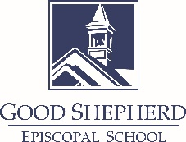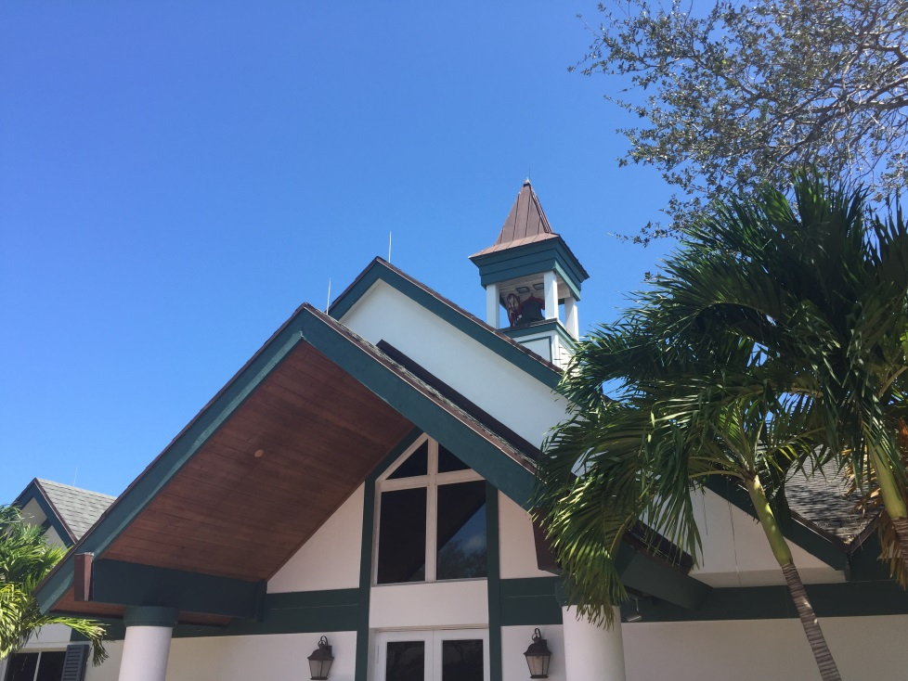

# Our School

Challenging Academics ♦ Critical Thinking ♦ Character Building

Creative Expression ♦ Christian Values

Good Shepherd offers half-day and full-day options for Early Learners ages 2 and 3 years old, and a full-day option for Pre-Kindergarten. Our Kindergarten and Grades 1- 5 allow students to transition seamlessly through the Elementary School years.

Our school day starts at 8:00AM and dismisses at 12:00PM (half-day) and 3:00PM (full-day). In addition, we offer flexible before-care and after-care between the hours of 7:45AM and 5:30PM.

We are accredited by the Florida Council of Independent Schools (FCIS) and a member of the National Association of Episcopal Schools (NAES).

**1993 – 2024**

**31Years of Excellence**

# Our History

In 1993, our School was founded as an outreach of the Church of the Good Shepherd with a simple goal: to enrich the lives of children of all faiths. It was a humble start with just two rooms, yet parents and parishioners envisioned so much more, and diligently worked to grow our preschool to include a fully accredited Elementary School.

Our main academic building was constructed in 1997, with a modern Art, Music and Science wing added in 2012. The shared 4-acre campus is within walking distance of the Tequesta Police Station, Tequesta Fire Station, Constitution Park, and Lighthouse Art Gallery.

Good Shepherd Episcopal School

Tequesta, Florida

**www.goodshepschool.com**

Mission Statement

We exist to provide our students with a firm foundation for life and learning in a safe environment that meets the needs of each student.

Episcopal Identity

Episcopal Schools are populated by families of diverse religious, cultural, and economic backgrounds. Episcopalians believe that our life is founded on the life of Jesus, and that as a Church we are called to offer the redeeming love of God to all people. Episcopal schools are a concrete expression of the Church’s care for young people and their families, and of the belief that God calls us to love all God’s children. An Episcopal school is comprehensive and inclusive.

* The unity of an Episcopal school is based on rite and tradition, rather than doctrine.
* An Episcopal school values reason as a way to true understanding.
* An Episcopal school has a concern for the well-being of society.
* An Episcopal school is founded on love.

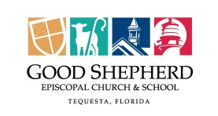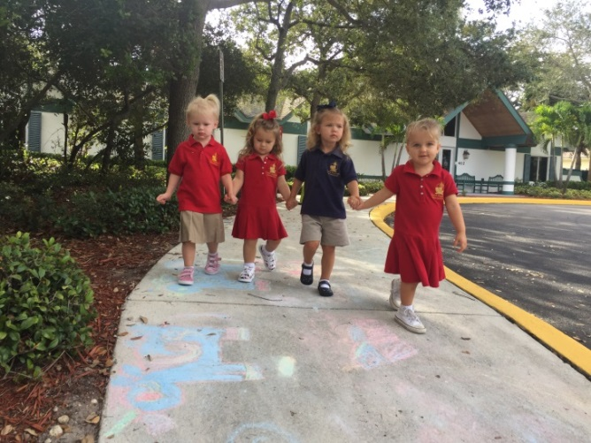

Fundraisers throughout the year, such as the Panther Open Golf Tournament and Pumpkin Patch, provide an important revenue stream that benefits all of Good Shepherd.

The School, with great participation from its Staff, initiates activities that appeal to all interests. Diverse field trips, after school activities and evening events all help bring our campus to life! Annual traditions include Pancake Races, Talent Show, and Field Day. STEM Night, International Night and our musical productions provide additional experiential learning opportunities, and bring church and school communities together.

*“Learning to Love,*

*Loving to Learn.”*

# Campus Life

You cannot walk onto our campus without immediately feeling a sense of community. You will find Staff, Parents and Community Volunteers working together toward a common goal. We boast an active Parents’ Association who partner with the school to deliver meaningful experiences, support community outreach, and organize important fundraisers. Events like the Daddy Daughter Dance and Movie Night on the Field build lifelong family bonds and create special childhood memories.

# Our Curriculum

Good Shepherd offers a curriculum rich in opportunities for all students. The program assures that students are challenged and supported while building strong skills, gaining valuable knowledge and developing substantial values. All aspects of the curriculum are intended to provide a “hands-on” learning experience and to develop analytical, critical thinking, and creative skills.

Students are presented with a range of experiences across the academic program. We offer differentiated instruction in the core subjects of Language Arts, Reading, Mathematics, Science and Social Studies.

This is enriched with weekly instruction which broaden the students’ working knowledge in STEM, Spanish, Technology, Library Literacy, Research, Physical Education, Visual Arts and Music. Students also participate in weekly Chapel service and regular outreach programs.

To best serve the needs of all our students, Good Shepherd provides Academic Support in both reading and math.  This support may be in the form of individual or group settings, and may include tools for either accelerated or remedial instruction.

“How” we teach is as important as “what” we teach.

We believe…

* our stimulating academic program prepares our students for success
* small class sizes promote problem solving skills and encourage creativity
* it is important to be responsible and respectful
* an atmosphere of trust and structured freedom is essential
* the best environment for learning is hands-on and interactive
* mistakes are learning opportunities that should be springboards to improvement
* our school teaches respect for the religious and cultural differences that exist in our community
* parents are welcomed, encouraged, and expected to be an integral part of their child’s education
* our administration and faculty should be role models for our students

Good Shepherd Episcopal School

Tequesta, Florida

**Page 2**